

Methodology and Theory of FCalc 2.0

By Joseph T. Realmuto

Origin of FCalc 2.0

In July of 2001 I created the first version of FCalc in order to fix the grossly inaccurate default MSTS train resistance. As such, the improvement in realism was enormous, and FCalc 1.0 became the defacto standard for those seeking realistic physics. I was able to obtain a reasonably good match to the three term Davis equations for train resistance using the two terms required by MSTS. I used mostly trial and error, and settled on what I thought was the best fit for a wide range of rolling stock types and speeds. While it was not necessarily the best fit possible, it was good enough for the purposes at the time, which was to replace the awful default values.

Shortly after FCalc 1.0 was released I was asked several times about the possibility of adapting it for rolling stock with solid bearings (friction bearings). At the time I was unable to do so because I lacked Davis resistance equations for solid bearings, and I also lacked the methodology for simulating the characteristics of solid bearing trucks in MSTS.

The first step towards updating FCalc occurred in April of 2002. By studying exactly how MSTS uses the friction parameter I was able to devise a new method of simulating the much higher starting resistance of solid bearing trucks. I posted regarding this new method on the Train-Sim.com forums. However, because I still lacked equations for solid bearing rolling stock, nothing further came of it at the time.

The first real steps towards FCalc 2.0 came in September of 2003. James Titus posted on Train-Sim.com about some modifications he had made to FCalc to simulate starting resistance. They were quite similar to the work I had done to simulate friction bearings over a year earlier. I exchanged several e-mails with him and examined his work, including his spreadsheets. He used spreadsheets to match his modified friction value curves to those produced by my FCalc 1.0 program. In the course of examining his work, I was inspired to take another look at what I had done with FCalc 1.0, and see if I could get better curve matching. The tentative answer was yes. I still did not want to update FCalc until I was able to also incorporate my work on solid bearings, so I filed the results for future use.

The final piece of the puzzle fell into place in late October of 2003. Dave Nelson posted some questions he had regarding friction in MSTS. As the discussion evolved and I taught Dave about how friction works in MSTS, I was able to refine my curve matching even more via a series of exchanges of Excel spreadsheets. Furthermore, Dave kindly furnished me with the Davis equations for solid bearings. I now had all I needed to go ahead and release a new, greatly improved version of FCalc. To be sure, there was still much to be done, but the major obstacles had been overcome, and it was only a matter of refining my methodology and bringing it all together.

The final steps consisted of obtaining Davis resistance equations for as many types of rolling stock as I could in order to make FCalc 2.0 as comprehensive as possible. Work I had done earlier assisting Clem Tillier with his TGV was instrumental in this regard for high-speed trains. For American freight trains Bob Boudoin’s very comprehensive physics work was a great source of empirical values which could be adapted into a new set of equations. A copy I had of a demo version of the Railsim train performance calculator confirmed some values I had only estimated, and several other sources, including some anecdotal information by former railroaders, completed the picture.

Methodology of FCalc 2.0

The discussion of FCalc 2.0 methodology must begin with a review of how MSTS calculates train resistance. MSTS uses ten terms in the friction parameter to calculate friction as follows:

Friction (
856N/m/s 0 1mph 2.61N/m/s 1.8
5.1N/rad/s 1 -1rad/s 0 1
)

The first set of five numbers in red are what is used to represent velocity dependent friction while the second five numbers represent friction on curves. It is the first set of numbers that we are interested in. These numbers represent the constants C1, E1, V2, C2, E2, respectively. In this case, C1=856N/m/s, E1=0, V2= 1mph, C2=2.61N/m/s, E2 = 1.8. These numbers are used by MSTS to calculate friction as follows according to the MSTS documentation:

F=C1*V^{E1} if V2<0
F=C1*V^{E1} if V≤V2
F=C1*V2^{E1} + C2*V2 + C2*(V-V2)^{E2} if V>V2

In these three equations A^{B} means A to the power of B. F is the friction in newtons (4.448222 newtons = 1 pound), and V is the velocity in meters/sec (1 meter/sec = 2.23693 mph). Note that I said according to the MSTS documentation. As it turns out, the documentation is incorrect. I did not discover this while working on FCalc 1.0 because V2 was small (1 mph), and therefore the discrepancy wasn’t enough to be measurable under the methods I was using at the time. The corrected equations are as follows:

F=C1*V^{E1} if V2<0
F=C1*V^{E1} if V≤V2
F=C1*V2^{E1} + C2*V2 + C2*V^{E2} if V>V2

Note that they are identical except for the case of V > V2. In that case the last term is C2*V^{E2}, not C2*(V-V2)^{E2}. If V2 is small, as it always was in FCalc 1.0, the discrepancy is small. In the case of FCalc 2.0, when V2 values as large as 6 mph are used, the error was quite significant. Once I noticed it, I adjusted all my spreadsheets to calculate MSTS friction using the correct method.

The biggest difference between FCalc 1.0 and FCalc 2.0 is the fact that there is no fixed value of E2 whereas FCalc 1.0 used E2=1.8 for most rolling stock and E2=1.86 for high-speed rolling stock. The purpose of this new method is to get the best fit possible between the Davis equation and the MSTS friction equation. Because MSTS uses only two terms while Davis uses three a perfect match is not possible, but the discrepancies over the speed range of interest are much smaller in FCalc 2.0.

Before proceeding any further it is necessary to digress and discuss the theory and history of estimating train resistance. The first person to comprehensively and scientifically measure the running resistance of trains was W.L. Davis in 1926. By measuring how long it took trains of various configurations to coast down over tracks of known gradients he was able to develop an empirical equation which would enable one to estimate the resistance of any train. Any complex function can be broken down into a infinite series of polynomials of the form A+Bx+Cx²+Cx³+Cx⁴+ …. In practice a finite number of terms are used depending upon the degree of accuracy required. For railroading purposes a second order polynomial equation turned out to be a good enough fit to the empirical data. Therefore, the generalized form of the Davis equation is R=A+B+CV² where R is resistance, V is velocity, and A,B, and C are coefficients which depend upon the type of rolling stock and units used for R and V. Furthermore, for most railway stock the A coefficient usually takes the form of A=A1*T + A2*N, where T is the mass and N is the number of axles. The B coefficient is usually proportional to the mass (i.e. B=B1*T), and the C coefficient is generally a product of the frontal area A and drag coefficient C_{D} (i.e. C=C_{D}*A).

The accuracy of the original Davis equations was independently verified over the years. Modern rolling stock with larger dimensions, higher weights, and roller bearings, as well as changes in track structure, made it necessary to modify the Davis equations to better fit observed empirical results. It should be noted that in all cases the Davis equations are only valid for speeds over 5 mph. Under that speed, the rolling resistance of bearings starts to increase. In the case of solid (also termed friction) bearings the increase is dramatic. In the case of roller bearings it is smaller but nevertheless present. It is difficult to model this increase because it depends upon temperature, type of bearing seal, length of bearing service, etc. As trains rarely spend any time in revenue service at speeds under 5 mph, no attempt has been made to do so other than to give rough values of starting resistance in terms of pounds per ton of train weight.

The best place to start looking at the methodology used in FCalc 2.0 is by examining how I simulated solid bearing trucks. Let’s take a 50-ton (45.359 metric ton) freight car as an example. This is about as typical as it gets for the time periods during which solid bearing trucks were in use. The Davis equation for solid bearing freight cars is R = 1.3T + 29N + 0.045TV + 0.0005AV² = 181 + 2.25V + 0.045V² with the appropriate values substituted, and assuming a frontal area of 90 ft². Note that for this Davis equation, and any others I will use in the remainder of this document, R is in pounds, V is in mph, A is in ft², and T is in short (US) tons. Also note that this equation is only valid at a speed of 5 mph or greater. Under that speed resistance starts increasing, and starting friction of rolling stock equipped with solid bearing trucks is generally around 20 to 25 lbs per ton of weight, and as much as 50 lbs/ton in cold conditions.

How can we simulate this in MSTS, especially the higher starting friction? Note that by looking at how MSTS calculates friction, we see that when V ≤ V2 only the term F=C1*V^{E1} is used. It is immediately obvious to anyone familiar with exponents that a negative value of E1 will indeed give a value of friction that increases as speed decreases. There is one problem with this, however. When speed reaches zero, friction will theoretically become infinite. As luck would have it, this problem does not occur in MSTS because the train speed never reaches exactly zero. This isn’t to say that negative exponents will not cause problems sometimes, but only if their magnitude is too high. I’ve found that E1 values higher than about –0.30 will start to cause problems such as cars jiggling or even jumping off the tracks. A great deal of experimentation measuring the starting resistance of a cut of cars resulted in my choosing –0.25 as the best compromise value. There are no side effects and the starting resistance for a 50-ton freight car will be around 1300 lbs, which is 26 lbs/ton. This is well within the range observed for solid-bearing trucks. Furthermore, I used a V2 value in the range of 5 to 6 mph to simulate the point at which resistance would start increasing. It was in the course of experimenting using this higher V2 value that I discovered the MSTS documentation to be in error as described on the last page, and I then corrected my equations.

This took care of the part under 5 mph. However, I was also interested in the greatest possible accuracy at speeds over 5 mph. I soon came to realize that no single value of E2 would give good results for rolling stock of different weights, so I had to decide between compromising the accuracy or devising a method to choose the value of E2 that resulting in the best fit in each individual case. I chose the latter course. The method I would use involved minimizing the RMS error at speeds above V2 up to some maximum speed. It was at this juncture that I realized there was no point in worrying about speeds higher than would ever be seen in normal service. FCalc 1.0 had used E2=1.8 as the value giving the best fit over the speed range of 0 to 150 mph. I had chosen 150 mph as it was the highest speed conventional trains were ever likely to see. I decided in FCalc 2.0 to use more realistic speed ranges, especially for freight. I picked 80 mph as the maximum freight speed. Therefore, I would pick the value of E2 that would give the smallest RMS error over the speed range of V2 to 80 mph. This method is commonly used for curve fitting, and is called least-squares regression. RMS error is calculated simply by squaring the difference between each pair of data points, summing these squared differences, dividing by the number of data points, and then taking the square root. If you consider the order of these operations in reverse (root, mean, and square), then it easy to see how the term RMS came to be.

Now that I had a rough methodology, I had to find the best way to do my calculations. I initially had to choose a value of C1. In FCalc 1.0 this was chosen simply be setting C1 equal to the Davis A coefficient in newtons. I continued to use this method for roller bearing trucks in FCalc 2.0 but found that it wouldn’t give the best possible fit for solid bearing trucks. After some experimentation, I found that the best overall value of C1 was to set the constant portion of the MSTS friction value equal to the Davis resistance at the speed of 0.6V2. To elaborate further, consider that when V>V2, F=C1*V2^{E1} + C2*V2 + C2*V^{E2}. Because C1, V2, and E1 are all constants, the first term is also a constant. Therefore, the final equation I used was:

C1=(A + 0.6BV2 + C[0.6V2]²)/V2^{E1}

Note that A, B, and C are the Davis coefficients. Because everything in FCalc 2.0 is done internally in metric, I used metric equivalents for all the Davis equations. By first setting C1, it was possible to calculate C2 if I assumed that the Davis and MSTS resistances were equal at some speed V_{EQ}. The speed V_{EQ} is called the FCalc=Davis speed, and the equation used to calculate C2 was as follows:

C2=(A + BV_{EQ} + CV_{EQ}² - C1*V2^{E1})/(V2 - V_{EQ}^{E2})

Once C1 and C2 were known, it was then possible to calculate the RMS error.

There was one remaining problem that needed to be overcome. I varied E2 from 1.0 to 2.0 in order to find the value giving the least RMS error. For each value of E2 I varied V_{EQ} from 30 mph up to 80 mph in 1 mph increments, and for each set of E2 and V_{EQ} I varied V2 from 5 to 6 mph in 0.1 mph increments. The problem I faced should be obvious by now-if I wanted to get the best E2 value (to within 0.001) I needed to calculate RMS error, which in and of itself consisted of hundreds of calculations, 1001*51*11, or 561,000 times! I had initially wanted to vary V2 in 0.01 increments but found that little was gained. That would have resulted in the need to calculate RMS error over 5 million times. Prior to streamlining my methods, I did indeed use all possible values just to make sure any shortcuts I took wouldn’t compromise the final accuracy. Needless to say, each calculation took several minutes on my 1.568 GHz machine, and it was necessary to speed things up. I found that I could simply keep V2 and V_{EQ} at midpoint values, and vary E2 only in order to quickly get very close to the final values. I then used this close value of E2, varied V2 and V_{EQ} over their entire ranges to find the set of values giving the smallest RMS error, incremented E2 by 0.001, varied V2 and V_{EQ} again, and so forth. I noted that once the optimum value was found, continuing to increment E2 and do all the calculations was pointless, so I stopped calculating as soon as the RMS error started getting larger. All of these enhancements gave the same results, but with only a few seconds of calculation time.

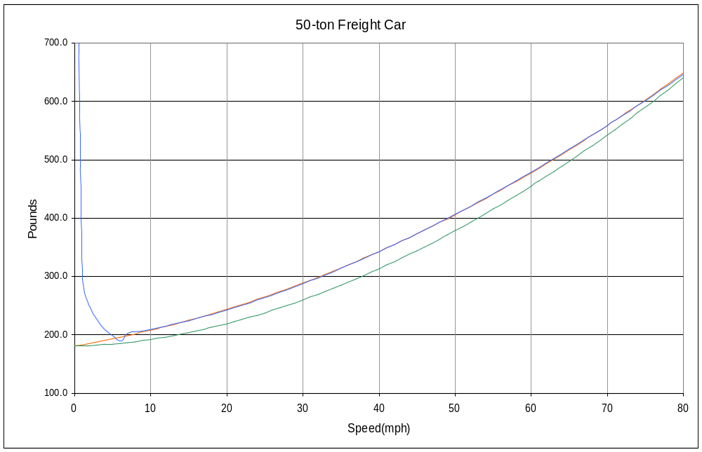 How does this new method work? The answer is very well indeed. Below is a graph of Davis versus FCalc 1.0 and FCalc 2.0 curves for the 50 US ton solid bearing freight car mentioned earlier:

Note that the FCalc 2.0 curve starts increasing below 5 mph as it should, and also note that above 6 mph it is virtually equal to the Davis curve (shown in red but mostly obscured by the blue FCalc 2.0 curve). Also note the relatively large error of the FCalc 1.0 curve (green). Because my FCalc 1.0 program didn’t have the equations for solid bearing trucks I had to hand calculate the values it would have given in order to obtain the above plot. Specifically, they were 805N/m/s 0 1mph 3.27N/m/s 1.8. Normally FCalc 1.0 errors are not so large, as the chart below for an 80-ton roller bearing freight car shows:
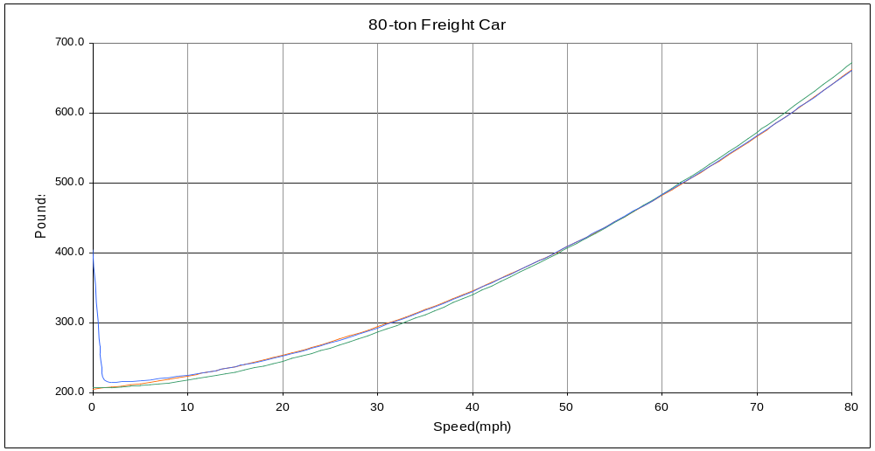
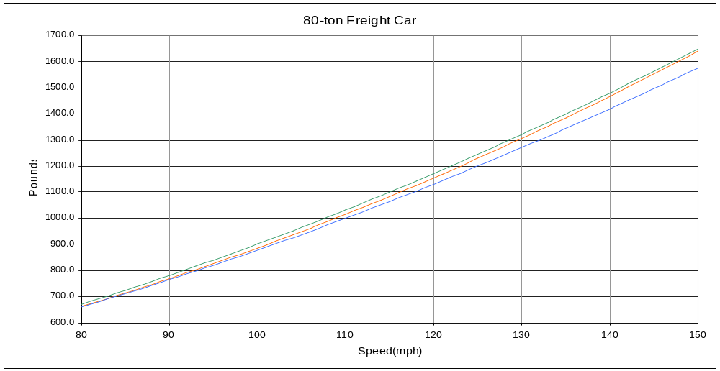Note that the FCalc 1.0 curve is slightly lower than the Davis curve from about 5 mph up to about 55 mph, at which point they are equal. Also note that above 55 mph it starts getting slightly higher. As in the previous case, the FCalc 2.0 and Davis curves are in virtual agreement above about 6 mph. Below that, the FCalc 2.0 curve is higher to simulate the increasing resistance even with roller bearings. The static resistance as measured in MSTS is around 500 pounds, or about 6.25 lbs/ton, which is within the range of measured starting resistances of 3 to 8 lbs/ton for roller bearings. One last graph of the 80-ton roller bearing freight car resistance shows that even though the FCalc 2.0 curve is optimized for the speed range of 0 to 80 mph, there is still fairly good agreement even at speeds up to 100 mph. Above 100 mph both the FCalc 1.0 (green) and FCalc 2.0 (blue) curves start to diverge from the Davis (red) curve. The FCalc 1.0 curve does indeed have better agreement with the Davis curve above 110 mph, but for freight operation that is entirely irrelevant.
Another graph shows that even when FCalc 2.0 optimizes for a wider speed range, the agreement with the Davis curve at lower speeds is still superior to that of FCalc 1.0. Shown below is the graph for a 55 metric ton roller bearing passenger car:
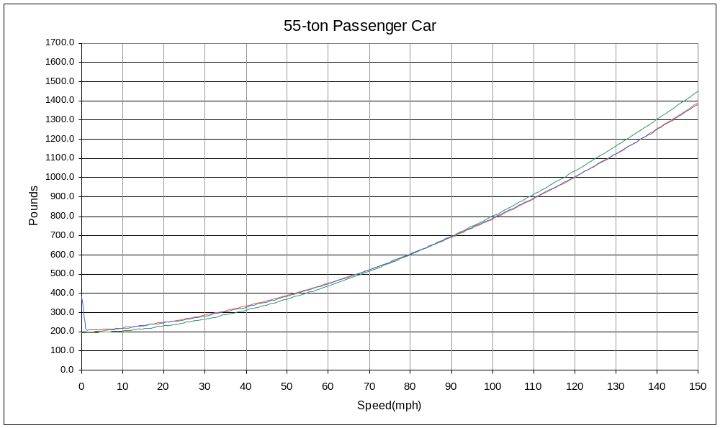As can be seen the FCalc 1.0 curve is lower than the Davis curve up to about 80 mph. Above that it is larger. The Davis and FCalc 2.0 curves are in virtual agreement over nearly the entire speed range. Although it can’t be seen on this graph, the RMS errors are indeed larger when optimizing for a wider speed range, but they are still generally under 0.5%. It is important to remember that the Davis equations are really just a model of a very complex physical phenomenon which is not easily measured to a high degree of accuracy. Because of this, it is likely that the FCalc 2.0 curve falls well within the error band of the Davis model whereas the FCalc 1.0 curve probably does not.

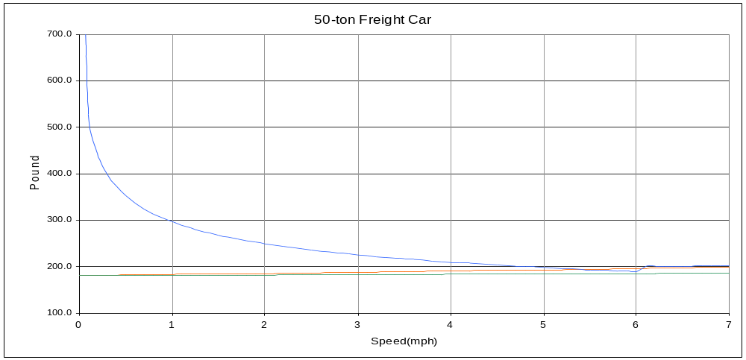 A final graph of the 50-ton solid bearing freight car shows in detail how the FCalc 2.0 resistance (shown in blue) increases under 5 mph:
The overlapping red and green lines are the Davis and FCalc 1.0 curves, respectively.

Methodology Behind The FCalc 2.0 Resistance Equations

As already noted, one of the main reasons for updating FCalc was not only to make it more accurate, but also to include many more choices in regards to rolling stock. To this end, I drew on several sources. Dave Nelson furnished me with equations for solid bearing rolling stock. I drew upon Bob Boudoin’s extensive physics work for more accurate equations for certain types of freight cars. I also used some data on high-speed trains from Clem Tillier and several other sources. In some cases I took a good educated estimate of what the equations were, and saw how well they agreed with empirical data where available.

I’ll start with a discussion of the three (actually four) bearing types used in FCalc 2.0. The most notable addition is solid bearings, also know as friction bearings. The term friction bearing was coined by Timken for marketing purposes in the 1930s in order to help them sell their new roller bearings, which they termed antifriction. This was really a misnomer as all bearings are antifriction. In any case the term fell into common usage, although I defer in this document to the original term solid bearing. Solid bearings are exactly that-the steel axle turns in a brass bearing lubricated by oil fed from oil soaked rags. Surprisingly, the rolling resistance of solid bearings was not much worse than roller bearings except at very low speeds, which explains why they were in use well into the 1950s. They were, however, prone to overheating and catching fire if not properly lubricated, especially at high speeds. It is a testament to the people who ran the railroads that they were able to run freight trains with solid bearings at speeds as high as 70 mph with few incidents. Of course, in time a few spectacular derailments traced to overheated solid bearings combined with increasing labor costs led to the requirement of roller bearings on all rolling stock used for interchange between railroads. The few remaining cars with solid bearings are used strictly for MOW duty.

The most important characteristic of solid bearings, at least as far as MSTS is concerned, is their rather high starting resistance. This is simulated by using a value of –0.25 for E1. The resistance at speeds above 5 mph is based on the set of Davis equations furnished to me by Dave Nelson. Translated into the format used for my other equations, these are as follows:

Locomotive R=1.3T + 29N + 0.03TV + 0.0024CAV²
Steam Locomotive R=1.3T + 29N + 0.03TV + 0.0024CAV² + 20DF
Passenger Car R=1.3T + 29N + 0.03TV + 0.00034AV²
Freight Car R=1.3T + 29N + 0.045TV + 0.0005AV²
Motor Car R=1.3T + 29N + 0.09TV + 0.0024CAV²

Note the use of area in the last term even for freight and passenger cars (both of which did not use area with the set of Davis equations used in FCalc 1.0). Also note the additional mechanical resistance of 20 lbs per ton for steam locomotives multiplied by the weight on drivers D and the additional factor F. This factor F is 1.0 for steam locomotives with regular connecting rods, 0.8 for ones equipped with lightweight roller-bearing connecting rods, and 0.5 for those equipped with poppet valves and Franklin Rotary Cam valve gear.

I further broke down motor cars into three categories-leading, middle, and end:

Leading Motor Car R=1.3T + 29N + 0.09TV + 0.0024CAV²
Middle Motor Car R=1.3T + 29N + 0.09TV + 0.00034AV²
End Motor Car R=1.3T + 29N + 0.09TV + 0.0006AV²

Only the last term is different between categories. I used the original equation for leading motor cars because the third term assumes the same form and values as a leading locomotive. The middle motor car basically has the same aerodynamic resistance as a passenger car, so the third term equals that of a passenger car. The end motor car has somewhat more drag than a middle one, but not anywhere near that of the leading motor car, so I estimated the value for the third term based on studies I’ve read regarding the relative contributions of leading and trailing locomotives to drag for high-speed trains. In FCalc 2.0 I used the term railcar instead of motor car as it seems to be a more common way of referring to EMUs and DMUs.

I also added an empty hopper to the list of freight cars. The relevant equation for a solid bearing empty hopper is:

Empty Hopper R=1.3T + 29N + 0.045TV + 0.0015CAV²

The first and second terms are obviously the same as for a standard freight car. The last term was estimated based on Bob Boudoin’s use of 6 to 9 N/m/s for the C2 value of empty hoppers in MSTS. I was able to get a range of possible values for the third Davis coefficient, and simply took the average. I used the exact same third term for roller bearing hoppers. Note that the aerodynamic drag is about three times that of a normal freight car due to the way an empty hopper catches the wind.

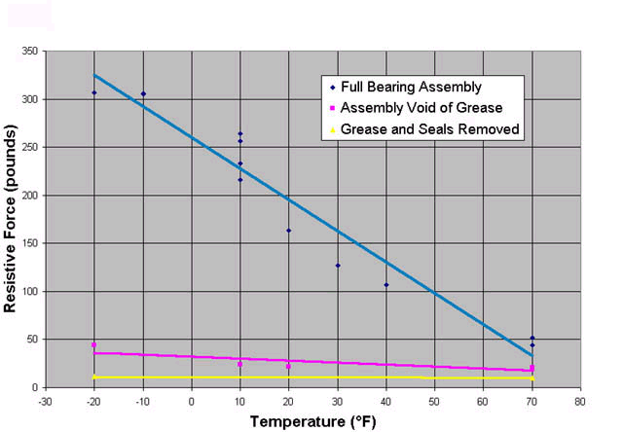
There are three types of roller bearings used in FCalc 2.0. They are standard roller bearings, optimized seal roller bearings, and labyrinth seal roller bearings. All roller bearings require seals to keep the grease from leaking out. The seals on standard roller bearings contribute as much as 50% of the total bearing drag. In the quest to save fuel, railroads are sometimes replacing standard roller bearings with types which have lower drag. The two main alternatives are optimized seal roller bearings and labyrinth seal roller bearings. Optimized seal bearings use lower drag seals while labyrinth bearings use a non-contact close tolerance series of barriers in a labyrinth pattern to contain the grease. Both are more expensive to produce than standard roller bearings. Bearing resistance is a function of time in service and temperature in addition to design. The following chart shows bearing start-up resistance versus temperature:

As can be seen the bearing seals and grease contribute an enormous amount towards the total drag, especially at lower temperatures when grease starts to solidify. In some cases the hardened grease can increase the drag by a factor of ten. Special greases need to be used when trains are mainly operated in very cold climates. I thought about including environmental factors in FCalc 2.0 to simulate this variation in resistance with temperature, but in the end I decided that it would be too complex. There is simply too much variability even among bearings of the same type to make any adjustments based on temperature meaningful. Additionally, I would need to incorporate adjustments in the aerodynamic portions of the Davis equations to simulate changes in air drag versus temperature. Air density increases as air temperature goes down, so this tends to increase aerodynamic drag with decreasing temperature. However, most heat engines develop more power at lower temperatures, and even electric locomotives may do so (due to decreased motor winding resistance). Thus, the temperature effects balance out to some extent, and it would be highly complex to try to include them anyway.

The next chart shows bearing resistance versus service mileage for the three types of roller bearings:

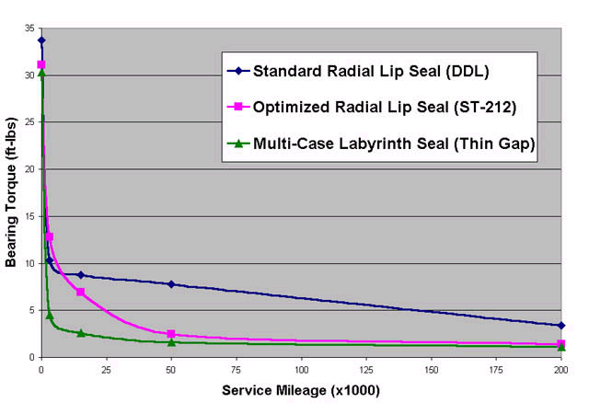
Standard roller bearings undergo a dramatic reduction in resistance as they are run in, mostly due to the seal seating itself, but also due to the bearing surfaces polishing themselves. The other two types of roller bearings show a smaller reduction, mostly due to bearing contact surface polishing action. Optimized seal and labyrinth bearings show little decrease in drag past about 100,000 miles, which is the point I used to determine the relative resistance of standard versus specialized seal roller bearings. Because the resistance of optimized seal and labyrinth bearings is virtually identical at 100,000 miles, I lumped them together in FCalc 2.0 under the term low-torque roller bearings and used one set of equations.

Translating the above chart into a new set of Davis equations was fairly straightforward. The difference in torque between standard and low-torque roller bearings at 100,000 miles is about 5 ft-lbs, or 10 ft-lbs per axle. For a standard 33-inch freight wheel (radius = 1.375 feet), this is a reduction of ~7 lbs per axle. For larger passenger car and freight wheels of 36 inches the reduction is 6.5 lbs. 42-inch locomotive wheels have a net reduction in drag of 6 lbs per axle. The portion of the Davis A coefficient proportional to weight remains unchanged. There were also adjustments in the Davis B coefficient to account for the reduction in velocity dependent rotational forces. I used roughly the ratio of per axle drag for standard versus low-torque roller bearings to determine the new B coefficient. For example, the per axle drag ratio for standard freight cars is 11/18.125 or 0.61. I multiplied the Davis freight B coefficient of 0.015 by this value to arrive at 0.0915. I rounded this up to 0.01 as it seemed a little low and I wanted a more even number. In all cases I erred on the side of adjusting too high rather than too low as I felt the main contribution of low-torque bearings was to reduce the constant A term of the Davis equation more than the velocity dependent B term. For low-torque roller bearings I used E1=-0.05 rather than E=-0.10 to simulate a lower starting resistance. Measured starting resistances in MSTS for standard roller bearing equipped cars ranged from 11.4 lbs/ton for very light (20 metric ton) cars to 5 lbs/ton for fully loaded cars (120 metric tons). Corresponding values for low-torque roller bearing equipped cars ranged from 5.3 lbs/ton to 2.9 lbs/ton depending upon weight.

In addition to the new bearing types I also added several new equations for modern freight cars based on Bob Boudoin’s work. I’ve already mentioned the empty hopper, which is the only new car type used with both solid and roller bearings. The other new types are modern cars which never existed in the era of solid bearings, and thus they are available with only the two options for roller bearings. The types are autorack, COFC (container-on-flat-car or double stack), and spine car. As before, I used Bob’s empirical values to arrive at approximate Davis equations. The new equations for standard roller bearing equipped cars are as follows:

Autorack R=1.5T + 18.125N + 0.015TV + 0.0007AV²
COFC R=0.6T + 20N + 0.01TV + 0.175V²
Spine Car R=0.6T + 20N + 0.01TV + 0.185V²

The last term for autoracks is 40% higher than for a standard box car of the same frontal area. The other two equations are very approximate but are based on the fact that TOFCs have about 15% more drag than COFCs, while spine cars are somewhat closer to TOFCs but still have smaller drag. If anyone can furnish me with better equations or new equations, I will gladly do minor updates of FCalc every few months to incorporate the new models.

I did a major revision of my equations for high-speed trains based on empirical studies of high-speed train resistance. The new equations for high-speed trains are:

Locomotive R=0.8T + 20N + 0.01TV + 0.0015CAV²
Passenger Car R=1.0T + 20N + 0.01TV + 0.0000037LAV²

It is important to note that the equation for the high-speed locomotive represents an average of the leading and trailing locomotives used on nearly all high-speed trains. I did this because most MSTS high-speed train models only use one model to represent both locomotives, thus requiring an average equation. The last term in the passenger car equation is based on length as well as frontal area. The study I read indicated that aerodynamic drag increases linearly with train length. I had also used a length-based last term in FCalc 1.0 for high-speed passenger cars but it was estimated. The source I read enabled me to replace my estimate with hard data, although my original estimate was pretty close (within 15%) if I assumed a frontal area of 10 meters², which is fairly typical for many high-speed passenger cars.

The high-speed train study enabled me to develop an equation for maglev trains. It takes the following form:

Maglev R=2.0T + 0.0036757LV + 0.0000037LAV² + 0.001143CAV²

The study determined that the term proportional to velocity consists partly of rolling resistance and partly of laminar air flow. Because maglevs have no wheels, only the portion due to laminar air flow is applicable, which is why the second term is proportional to length only and not to weight. The last two terms are aerodynamic drag proportional to velocity². The first portion is exactly the same as for high-speed passenger cars. The second portion is based on the drag produced by just the front and rear surfaces. This is why it is smaller than the corresponding term for a high-speed locomotive. The drag from the sides is not included because it is already included in the first portion. The single term proportional to weight only represents the magnetic drag of the vehicle. This is highly variable among maglev types, but 2 lbs/ton seems to be a ballpark figure. Because maglevs are a relatively new technology, I don’t expect that a generic set of equations for them exist. My equation represents a highly educated estimate but it should give fairly good results. However, I’m not entirely sure if the Davis model is valid when speeds are an appreciable fraction of the speed of sound, as they are for maglevs.

The appendix has a complete listing of all the equations used in FCalc 2.0. I used all three bearing types for railcars, freight cars, and passenger cars. Steam locomotives are available with both solid and standard roller bearing options. The mechanical term of 20 lbs/ton is not used for roller bearing steam locomotives on the assumption that roller bearings are used for all bearing surfaces, including connecting rods. The equation for locomotives refers to diesel and electric locomotives only. I did not include an option for solid bearings because they were not used on either diesel or electric locomotives to the best of my knowledge. For early box cab electric motors using reciprocating connecting rods the equation for solid bearing steam locomotives might give better results.

Guidelines For Using FCalc 2.0

While FCalc 2.0 strives to faithfully duplicate the Davis equations it is based on, it can only be accurate if supplied with accurate information. Therefore, a series of guidelines are in order. The biggest change that will be noticed from FCalc 1.0 besides the addition of many new types of rolling stock will be the fact that frontal area is used for virtually everything except TOFCs, COFCs, and spine cars. This is to better estimate aerodynamic drag as a larger vehicle will obviously have more drag whether it is in front of the train or in the middle. The best way to accurately measure frontal or cross-sectional area is from a scale drawing of the car in question, or from a scale model if available. The size of the bounding box can also be a guide, provided it coincides exactly with the top, sides, and bottom of the vehicle. The area of rectangular body shapes is easily calculated if the height and width are known. More complex shapes may require laying out a front view on graph paper, counting the number of squares covered, and converting the result to meter². Absolute accuracy is not required, but it is a good idea and fairly easy to be within a few percent of the true value. In the absence of data, the program will suggest defaults of 10.2 meter² for freight cars, 11.2 meter² for passenger cars, and 16.35 meter² for autoracks. Do not use the suggested values unless you lack better data. Chances are if you made the 3D model you already have what you need to estimate frontal area to a high degree of accuracy. In cases where a certain type of car is known to have a larger amount of aerodynamic drag than most cars of similar size, a value of frontal area larger than the true value can be used. You can adjust the value up or down until you get the desired results.

Probably the most important parameters are the weight and number of axles as they influence rolling resistance. Rolling resistance is responsible for a good portion of the total train resistance, especially at speeds under 50 mph. Because the mass not only influences the calculated friction value but also how quickly the rolling stock accelerates, decelerates, behaves on gradients, and so forth, it is very important to obtain as accurate a value as possible. Even small differences can have a noticeable effect in train handling. Fortunately, the weight, or more accurately the mass, is usually available to a fairly high degree of accuracy. The number of axles is obviously known exactly. For trains with shared or articulated trucks use one-half the number of axles on each shared truck and all the axles on unshared trucks. For instance, a TGV center coach riding only on shared trucks will have two axles while an end coach with one shared and one normal truck will have three. The type of bearing will also have an effect on train handling, and it is visually obvious which cars have solid bearings and which have roller bearings. Less obvious are those cars which use low-torque roller bearings. If this information is not available it is best to assume standard roller bearings. Even within cars of a given type, some railroads may elect to retrofit their cars with low-torque roller bearings while others will not.

While the “big three” are very important, another parameter of some importance is the drag coefficient. You are generally only asked for the drag coefficient if the vehicle is in front of the train. Basically, this means locomotives and leading motor cars only. For a good portion of the rolling stock out there it is pretty safe to assume a value of 1. If it looks boxy, you probably can’t go wrong picking 1 for the drag coefficient. However, if you have a locomotive that will only be used as one of the following units in a multiple unit lash-up then it is probably more realistic to use a value of less than 1 for the drag coefficient. A value around 0.7 might be appropriate in that case. For cases when the leading unit is streamlined, appropriate values would be 0.65 to 0.75 if partially streamlined, and 0.5 or less if fully streamlined. I’ve found that a value of 0.35 for very streamlined trains like the TGV combined with proper frontal area will give results that are in near perfect agreement with empirically measured values. Because data regarding drag coefficients is very hard to come by, the best method is to take a look at the locomotive, estimate the degree of streamlining, and choose an appropriate value based on the guidelines I just gave for various types of locomotives. Slight streamlining might mean a drag coefficient of 0.9, something like an F7 might be around 0.6 to 0.7. An HHP-8 might be about 0.55. A TGV or bullet train will probably be under 0.4, and in some cases under 0.3. All of these examples only apply to units in front of the train. Trailing units will have less drag, and the drag coefficient should reflect this. A value of from 30% to 70% of the leading unit’s drag coefficient is appropriate, depending upon how closely coupled the units are. For instance, an F7 or PA B-unit might use a drag coefficient of 0.25, while an unstreamlined freight locomotive might use 0.6 to 0.7. In the end a good portion of the train resistance is made up of the cars being pulled, not the locomotive(s), so errors of 20% or more in the drag coefficient won’t have that large of an effect except for a very short train.

The final parameter used is length, and this is only in the case of high-speed passenger cars and maglevs. The length can be easily found by simply examining the last value in the size parameter in the .eng or .wag file. Provided the size parameter is set properly so that the coupler faces are touching, this value will be accurate to within one or two tenths of a meter. This is adequate enough for the purposes of FCalc 2.0 and MSTS.

FCalc 2.0 is capable of recalculating the friction value for a new speed range after a value using the default speed range is computed. The default speed range is 80 mph for freight cars and locomotives, 150 mph for passenger cars and locomotives, 250 mph for high-speed trains, and 350 mph for maglevs. The only exceptions are 100 mph for solid bearing passenger cars and 125 mph for steam passenger locomotives. There is generally not much to be gained accuracy-wise by using a speed range under 80 mph, but you can do so if you want to. In the case of certain types of rolling stock, a more appropriate speed range might be the design speed of the rolling stock, or the top geared speed of the locomotive. In general it is a good idea to add 5 mph to these values just to cover slight excursions over the limits. For example, an Amfleet coach and AEM-7 locomotive are both rated for 125 mph. 130 mph will give slightly more accurate results than the default 150 mph speed range. For most freight locomotives and cars the default 80 mph range will suffice. Because average errors are higher with larger speed ranges it is an especially good idea to recalculate in this manner for high-speed trains. Reducing the range from 250 mph down to, say, 210 mph will have a noticeable effect on error. In the case of railcars, the speed range must be entered all the time. This is because there is such a wide range of EMU and DMU design speeds that any default value would be unsatisfactory. In nearly all cases I’ve noticed that optimizing for a speed range of less than 60 mph is pointless. The RMS error actually increases slightly for smaller speed ranges. I stopped short of setting 60 mph as the minimum top speed in the FCalc 2.0 program but I don’t recommend using anything smaller. The only caveat with optimizing for a speed range other than the default is that it might be a good idea to place a comment near the friction value stating the speed range that was used so that others can duplicate the results. In fact, I recommend also including in the comment the frontal area, and if applicable the drag coefficient and/or length. The purpose of this is so that others can easily see how the friction value was arrived at.

Another interesting addition in FCalc 2.0 is the special custom Davis coefficient optimization. If you have somehow managed to obtain Davis coefficients for a particular piece of rolling stock you can enter those coefficients, along with the speed range and bearing type, and have an optimized MSTS friction value calculated for you. The program accepts inputs in either English or Metric format. The English format uses mph for velocity and pounds for resistance. The Metric format uses meters/sec for velocity and newtons for resistance. These are the most commonly seen units for Davis equations. Some metric Davis equations use km/hr for speed instead of meters/sec. In that case you must first convert to the units used by FCalc 2.0. This can be done by multiplying the B coefficient by 3.6 and the C coefficient by 3.6², or 12.96. The A coefficient is unchanged.

In order to ensure compatibility with future train simulators I outputted the Davis equations along with the MSTS friction value. If these new simulators use the same method to calculate train friction as MSTS 1 then the usual five term friction value is available. On the other hand, should the programmers decide to use the Davis coefficients instead then those coefficients will be available on the output screen as well. In the interests of accuracy I recommend that the programmers of any new train simulators do not use the Davis equations for speeds under 5 mph. I suggest instead having another set of equations (possibly an inverse exponential) apply under 5 mph, combined with a variable for static friction (to prevent the inverse exponential from becoming infinite at low speeds).

Finally, it is important to remember that train resistance is but one part of realistic physics. Proper values for locomotive power, tractive effort, control settings, and so forth are very important. Brake parameter settings also have a great influence on how realistic the sim ultimately will feel. All of these things have been addressed by myself and others to some extent. Discussing them here is beyond the scope of this document. I can only say that many visually attractive models have suffered due to poor physics. In many cases the very unrealistic default physics are used without further modification despite the ready availability of alternatives.

Using the FCalc 2.0 Spreadsheets

In order to enhance the usefulness of FCalc 2.0 I have included a series of Excel spreadsheets for each of the major types of rolling stock. In most cases each sheet contains one worksheet for each of the subtypes of that particular type of rolling stock. For example, the spreadsheet for standard freight cars, “FCalc 2.0 Standard Freight.xls”, contains worksheets for solid, roller, and low-torque roller bearing equipped cars. These sheets are designed to allow the user to see graphs of the MSTS friction value calculated by the FCalc 2.0 program, and to compare those graphs to the Davis equations. Unfortunately, Excel in and of itself is incapable of doing the complex algorithm needed to determine the best fit MSTS friction value, and hence the spreadsheets are only a supplement to, rather than a replacement for, the FCalc 2.0 program.

The best way to describe how to use these sheets is via a demonstration. Take the “FCalc 2.0 Standard Freight.xls” spreadsheet, for instance. In order to use it properly you must first find the worksheet for the type of bearing the car has. All of the worksheets have typical values for weight, frontal area, axles, and so forth already filled in along with the FCalc 2.0 results using those values. You simply replace the metric values for weight, number of axles, and frontal area (cells B2,B3, and B4) with your own values. You then calculate the MSTS friction value using the FCalc 2.0 program and the same three values you just entered on the worksheet. After the FCalc 2.0 program gives you an MSTS friction value you enter the V2, E2, and Davis=FCalc speed in the appropriate cells on the worksheet. C1 and C2 are calculated automatically for you. If all goes well you should now see a graph of how your new MSTS friction value compares to the Davis equation over the entire speed range. There are also graphs of the error and percentage error over the same speed range.

Appendix

Summary of English Resistance Equations Used in Fcalc 2.0

Standard Roller Bearings

Locomotive R=1.3T + 29N + 0.03TV + 0.0024CAV²
Steam Locomotive R=1.3T + 29N + 0.03TV + 0.0024CAV² + 20DF
Standard Freight Car R=1.5T + 18.125N + 0.015TV + 0.0005AV²
Autorack R=1.5T + 18.125N + 0.015TV + 0.0007AV²
Empty Hopper R=1.5T + 18.125N + 0.015TV + 0.0015AV²
TOFC R=0.6T + 20N + 0.01TV + 0.20V²
Spine Car R=0.6T + 20N + 0.01TV + 0.185V²
COFC(Double Stack) R=0.6T + 20N + 0.01TV + 0.175V²
Passenger Car R=1.3T + 29N + 0.03TV + 0.00034AV²
Leading Motor Car R=1.3T + 29N + 0.06TV + 0.0024CAV²
Middle Motor Car R=1.3T + 29N + 0.06TV + 0.00034AV²
End Motor Car R=1.3T + 29N + 0.06TV + 0.0006AV²

Optimized Seal/Labyrinth Low-Torque Roller Bearings

Locomotive R=1.3T + 23N + 0.02TV + 0.0024CAV²
Standard Freight Car R=1.5T + 11N + 0.01TV + 0.0005AV²
Autorack R=1.5T + 11N + 0.01TV + 0.0007AV²
Empty Hopper R=1.5T + 11N + 0.01TV + 0.0015AV²
TOFC R=0.6T + 13.5N + 0.007TV + 0.20V²
Spine Car R=0.6T + 13.5N + 0.007TV + 0.185V²
COFC(Double Stack) R=0.6T + 13.5N + 0.007TV + 0.175V²
Passenger Car R=1.3T + 22.5N + 0.019TV + 0.00034AV²
Leading Motor Car R=1.3T + 22.5N + 0.038TV + 0.0024CAV²
Middle Motor Car R=1.3T + 22.5N + 0.038TV + 0.00034AV²
End Motor Car R=1.3T + 22.5N + 0.038TV + 0.0006AV²

Friction Bearings

Steam Locomotive R=1.3T + 29N + 0.03TV + 0.0024CAV² + 20DF
Standard Freight Car R=1.3T + 29N + 0.045TV + 0.0005AV²
Empty Hopper R=1.3T + 29N + 0.045TV + 0.0015AV²
Passenger Car R=1.3T + 29N + 0.03TV + 0.00034AV²
Leading Motor Car R=1.3T + 29N + 0.09TV + 0.0024CAV²
Middle Motor Car R=1.3T + 29N + 0.09TV + 0.00034AV²
End Motor Car R=1.3T + 29N + 0.09TV + 0.0006AV²

High-Speed Train

Locomotive(front/rear) R=0.8T + 20N + 0.01TV + 0.0015CAV²
Passenger Car R=1.0T + 20N + 0.01TV + 0.000003702LAV²

Maglev

Maglev R=2.0T+3.6757e⁻³LV+(3.702e⁻⁶L+0.001143C)AV²

Summary of Metric Resistance Equations Used in Fcalc 2.0

Standard Roller Bearings

Locomotive R=6.3743T + 128.998N + 0.32905TV + 0.57501CAV²
Steam Locomotive R=6.3743T + 128.998N + 0.32905TV + 0.57501CAV² + 98.0667DF
Standard Freight Car R=7.3550T + 80.625N + 0.16453TV + 0.11979AV²
Autorack R=7.3550T + 80.625N + 0.16453TV + 0.16771AV²
Empty Hopper R=7.3550T + 80.625N + 0.16453TV + 0.35938AV²
TOFC R=2.9420T + 88.964N + 0.10968TV + 4.45168V²
Spine Car R=2.9420T + 88.964N + 0.10968TV + 4.11780V²
COFC(Double Stack) R=2.9420T + 88.964N + 0.10968TV + 3.89522V²
Passenger Car R=6.3743T + 128.998N + 0.32905TV + 0.08146AV²
Leading Motor Car R=6.3743T + 128.998N + 0.65811TV + 0.57501CAV²
Middle Motor Car R=6.3743T + 128.998N + 0.65811TV + 0.08146AV²
End Motor Car R=6.3743T + 128.998N + 0.65811TV + 0.14375AV²

Optimized Seal/Labyrinth Low-Torque Roller Bearings

Locomotive R=6.3743T + 102.309N + 0.21937TV + 0.57501CAV²
Standard Freight Car R=7.3550T + 48.9305N + 0.10968TV + 0.11979AV²
Autorack R=7.3550T + 48.9305N + 0.10968TV + 0.16771AV²
Empty Hopper R=7.3550T + 48.9305N + 0.10968TV + 0.35938AV²
TOFC R=2.9420T + 60.051N + 0.07678TV + 4.45168V²
Spine Car R=2.9420T + 60.051N + 0.07678TV + 4.11780V²
COFC(Double Stack) R=2.9420T + 60.051N + 0.07678TV + 3.89522V²
Passenger Car R=6.3743T + 100.085N + 0.20840TV + 0.08146AV²
Leading Motor Car R=6.3743T + 100.085N + 0.41680TV + 0.57501CAV²
Middle Motor Car R=6.3743T + 100.085N + 0.41680TV + 0.08146AV²
End Motor Car R=6.3743T + 100.085N + 0.41680TV + 0.14375AV²

Friction Bearings

Steam Locomotive R=6.3743T + 128.998N + 0.32905TV + 0.57501CAV² + 98.0667DF
Standard Freight Car R=6.3743T + 128.998N + 0.49358TV + 0.11979AV²
Empty Hopper R=6.3743T + 128.998N + 0.49358TV + 0.35938AV²
Passenger Car R=6.3743T + 128.998N + 0.32905TV + 0.08146AV²
Leading Motor Car R=6.3743T + 128.998N + 0.98716TV + 0.57501CAV²
Middle Motor Car R=6.3743T + 128.998N + 0.98716TV + 0.08146AV²
End Motor Car R=6.3743T + 128.998N + 0.98716TV + 0.14375AV²

High-Speed Train

Locomotive(front/rear) R=3.9227T + 88.964N + 0.10968TV + 0.35938CAV²
Passenger Car R=4.9033T + 88.964N + 0.10968TV + 0.00291LAV²

Maglev

Maglev R=9.8066T + 0.12LV + (0.00291L + 0.27388C)AV²

Unit Conversions

1 meter² = 10.76391 ft²
1 ft² = 0.09290304 meter²
1 meter/second = 3.6 km/hr = 2.23693 mph
1 mph = 1.609344 km/hr = 0.44704 meter/second
1 metric ton(tonne) = 1.102311 short ton = 2204.622 pounds
1 short(US) ton = 0.907185 metric ton = 2000 pounds
1 meter = 3.28084 feet
1 foot = 0.3048 meter
1 pound = 4.448222 newtons
1 newton = 0.224809 pounds

Sources

- Introduction To Transportation Engineering and Planning by Edward K. Morlok, copyright 1978 McGraw-Hill, Inc.

- Baldwin Red Book, 1939

- Energy Consumption and Running Time For Trains by Piotr Lucaszewicz, 2001 Department of Vehicle Engineering, Royal Institute of Technology, Stockholm, Sweden (http://www.lib.kth.se/Fulltext/lukaszewicz010608.pdf)

- Bearing Rolling Resistance - Technical Forum 03-1 Brenco, Inc. (no author or date given) (http://www.brencoqbs.com/forums/0301.htm)

- Railsim Train Performance Calculator Demo (http://www.RAILSIM.com)

Credits

Kevin Arceneaux-beta testing
Frank Bandre-beta testing
Nick Chillianis-modified steam locomotive equations
Bob Boudoin-empirical data for many types of freight equipment, extensive physics modifications, extensive beta testing
Sidney Broughton-another graphical version of FCalc (not yet released)
Richard Gibb-beta testing
Okrasa Ghia-graphical version of FCalc
Todd Jones-locomotive engineer, empirical data for many types of freight equipment
Derek Morton-programmer of EngMod, volunteered to program future GUI version of FCalc 2
Dave Nelson-solid bearing equations, extensive help incorporating solid bearings into Fcalc, help with spreadsheets
Cyndi Richards-beta testing
Ian Roberts-suggestions for dealing with steam locomotives and friction
bearings, spreadsheets incorporating FCalc
Clem Tillier-data on high-speed trains
James Titus-ideas to incorporate solid bearings into Fcalc, help with spreadsheets
Richard Wilms-anecdotal information about solid (friction) bearings

Credits are in alphabetical order

